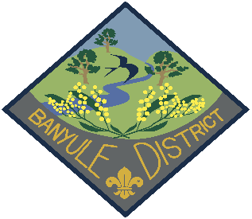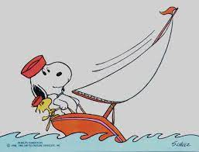

Banyule District Cubs End of Year Activity
Try Sailing Day at the Scouts/Guides Sailing Centre
40a Jetty Rd.
Sandringham
Date: Saturday 12th November 2022
Cost $30 per Cub
Payment details are:
Banyule District Cub Scouts
BSB 633 000
A/C 152262291
For the reference please use:
” November Sailing Day” with the Cub’s name & Group (Rosanna)
## For catering purposes:
We need numbers for both Cubs & Adults
Along with Any dietary requirements
….Please email Akela (Wayne) on akela@rosannacubs.org

What to bring:
Wear Cub Scout Uniform to and from the event.
Personal Information Record from rosannacubs.org Paperwork page, or print out from Care Monkey/Operoo
Change of clothes, bathers, towel, closed toe shoes (no crocs or thongs!) sunscreen, drinking water & hat.
RVSP: Friday 4th November

Pre-requisites: All participants must be able to swim 50 meters unassisted
Adults (Leader & /or Adult Helper) must hold Certificate of Adult Membership in Scouting & current WWC.
Youth Members (Cubs) must be registered members of Scouting

Activity Location:
Scout Water Activity Centre, 40a Jetty rd. Sandringham
Time Overview:
Start time 9.30 am, on water activities start from 10.00
Lunch 12pm to 1 pm
End 3.30 pm
Getting to the event and home.
Saturday 12th November 2022
Leave Rosanna Station on the at 8.18am train
- use the rear carriage of the train as the meeting point
We’ll change at Flinders St Station to go to Sandringham.
** Require Myki card, using Zones 1 & 2.
Depart Sandringham on the 3.57 and arrive at Rosanna 5.16pm
Yours In Scouting
Pete Owens
Banyule DLCS
Mb 0408 323 083
Em: peter_d_owens@bigpond.com

